How to Run the Instructor Attendance Report
- On the left side, click the 3 bars beside the Starfish name
- From the left menu, select Students
- Click on the Attendance tab
- On the right side of the Attendance Screen, under the Choose Students By section, click on the Course Section drop down menu to choose a section for which to report.
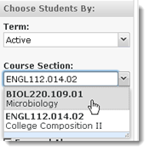
- Select Attendance Report from the action bar to download the report as an Excel document.
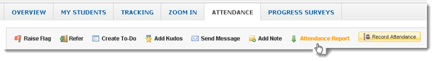
- Open the downloaded file in Excel which will be named for the reported course section.

