Undergraduate Survey
Total Responses: 423
Developing leadership skills Mean: 3.69
Response | Value | Frequency | Percent | Graph
Excellent Good Average Fair Poor N/A | 5.00  4.00  3.00  2.00  1.00  0.00 | 160  152  43  10  4  54 | 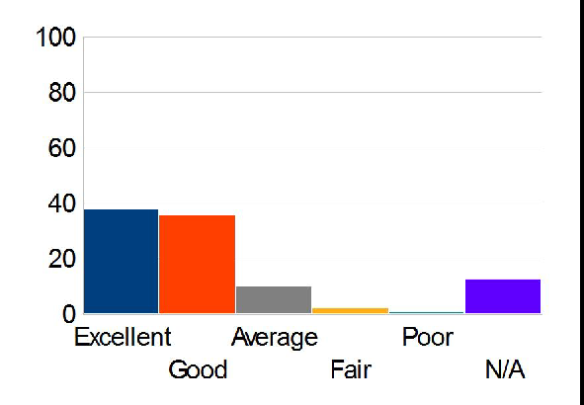  37.83  35.93  10.17  2.36  0.95  12.77
Total Valid |  | 423 | 100.00
Total |  | 423 | 100.00
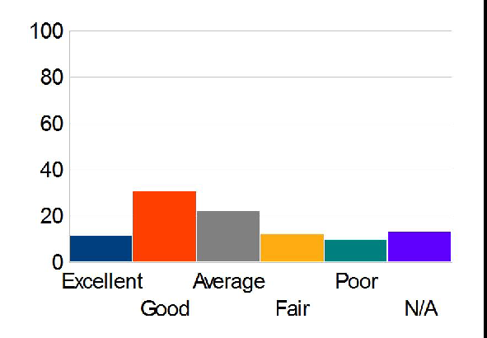
Lab equipment and appearance Mean: 2.82
Response | Value | Frequency | Percent | Graph
Excellent Good Average Fair Poor N/A | 5.00  4.00  3.00  2.00  1.00  0.00 | 49  130  94  52  42  56 | 11.58  30.73  22.22  12.29  9.93  13.24
Total Valid |  | 423 | 100.00
Total |  | 423 | 100.00

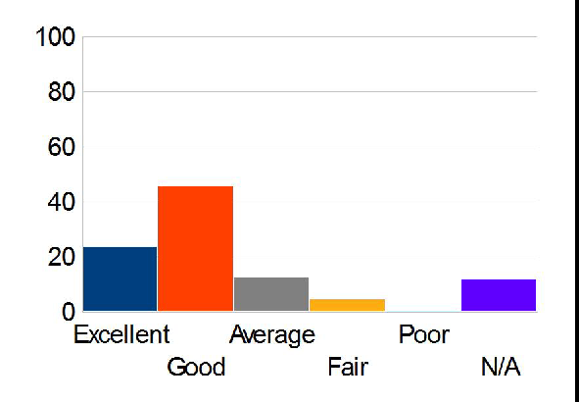
Quality of general faculty Mean: 3.51
Response | Value | Frequency | Percent | Graph
Excellent Good Average Fair Poor N/A | 5.00  4.00  3.00  2.00  1.00  0.00 | 101  194  54  20  3  51 | 23.88  45.86  12.77  4.73  0.71  12.06
Total Valid |  | 423 | 100.00
Total |  | 423 | 100.00
Quality of Faculty in your Major Mean 3.64
Response | Value | Frequency | Percent | Graph
Excellent Good Average Fair Poor N/A | 5.00  4.00  3.00  2.00  1.00  0.00 | 156  144  46  21  3  53 | 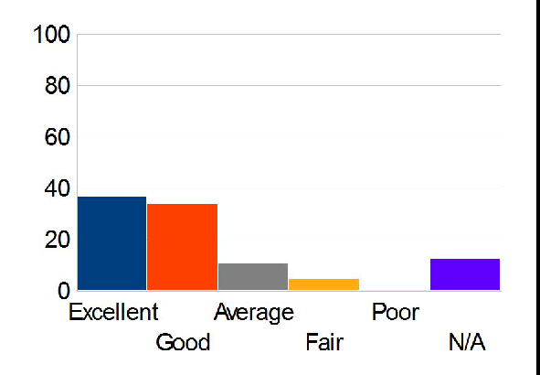  36.88  34.04  10.87  4.96  0.71  12.53
Total Valid |  | 423 | 100.00
Total |  | 423 | 100.00

Career counseling Mean: 3.57
Response | Value | Frequency | Percent | Graph
Excellent Good Average Fair Poor N/A | 1.00  2.00  3.00  4.00  5.00  6.00 | 54  126  66  20  15  142 | 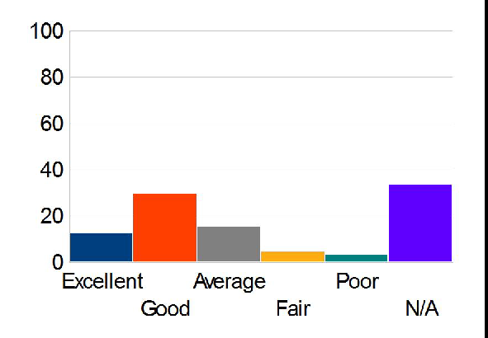  12.77  29.79  15.60  4.73  3.55  33.57
Total Valid |  | 423 | 100.00
Total |  | 423 | 100.00

Preparation for employment Mean: 3.69

Response | Value | Frequency | Percent | Graph
Excellent Good Average Fair Poor N/A | 5.00  4.00  3.00  2.00  1.00  0.00 | 115  175  71  30  11  21 | 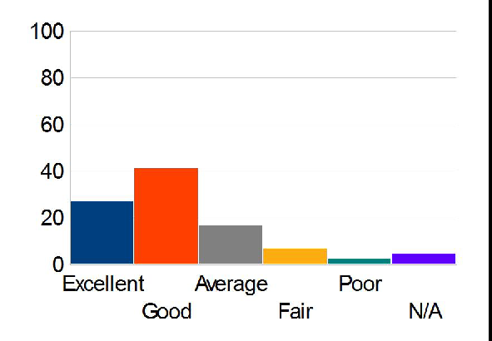  27.19  41.37  16.78  7.09  2.60  4.96
Total Valid |  | 423 | 100.00
Total |  | 423 | 100.00

