RECORDING PRELIMINARY FIXED ASSETS IN FAMIS

PRELIMINARY FIXED ASSETS-WHY?
To comply with the Texas A&M University System ASSET MANAGEMENT RULES.
To bring TAMUK in line with other SYSTEM PARTS.

WHAT DOES PFA MEAN TO YOUR DEPARTMENT?
More departmental control over your assets.
Provide access to the asset records of a Department.

HOW WILL THIS WORK IN FAMIS:
“Controlled” or “Fixed Asset” object codes--- 5775-5788; 8410-8455.
Fixed Assets--Items over $5000
Controlled--certain items between $500 and $5000 (firearms, computers, printers, TVs, VCRs, Camcorders, Cameras, Stereo Systems and Projectors—digital only, not mounted).
If your purchase order includes object codes within these ranges, the Preliminary Fixed Assets screens must be completed before the Receiving Function, screens 321-326 can be CLOSED. In other words, your purchase cannot be paid until this new function is finished.
You can start the Receiving activity first, if you prefer, but if PFA object codes are included, closing of receiving will not be allowed. You will be prompted to complete the PFA screens.

NOW-the good news:
Preliminary Fixed Assets only involves five entry screens. Presented below is the procedure for accessing and completing these screens.

FAMIS TRAINING MODULE:
EXAMPLE:
Type M36 at screen field, press ENTER.
M36 will be displayed.

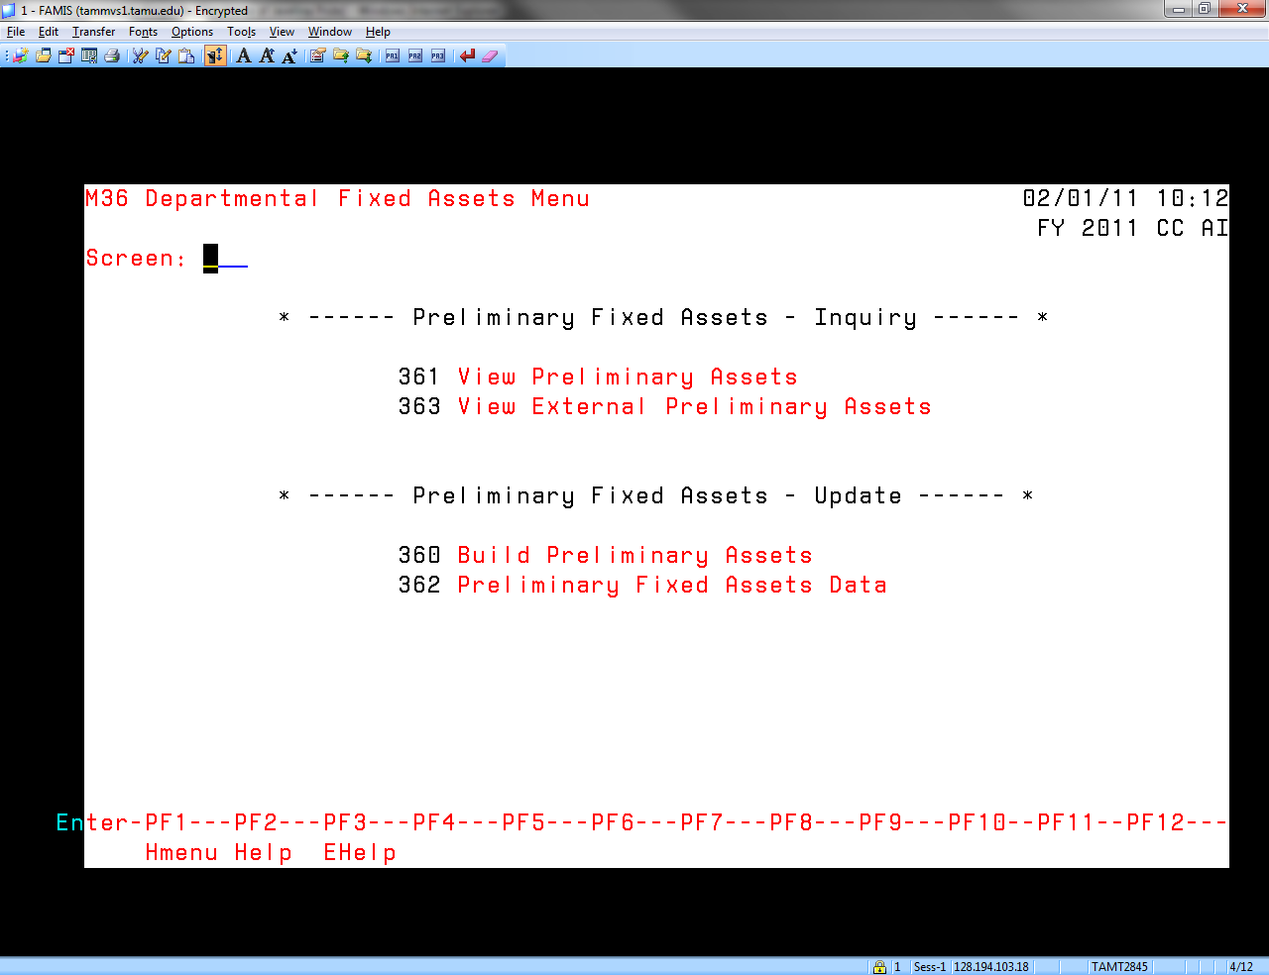

Type 360 at screen field, press ENTER.
Screen 360 will be displayed.
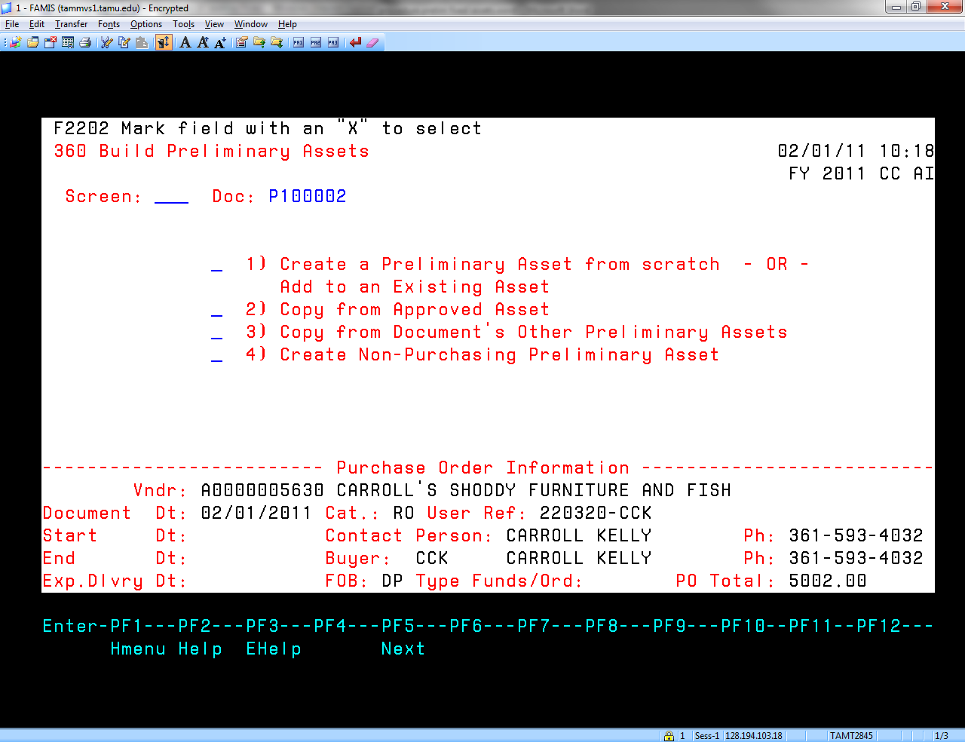

Place an X beside the operation you desire. Press ENTER.
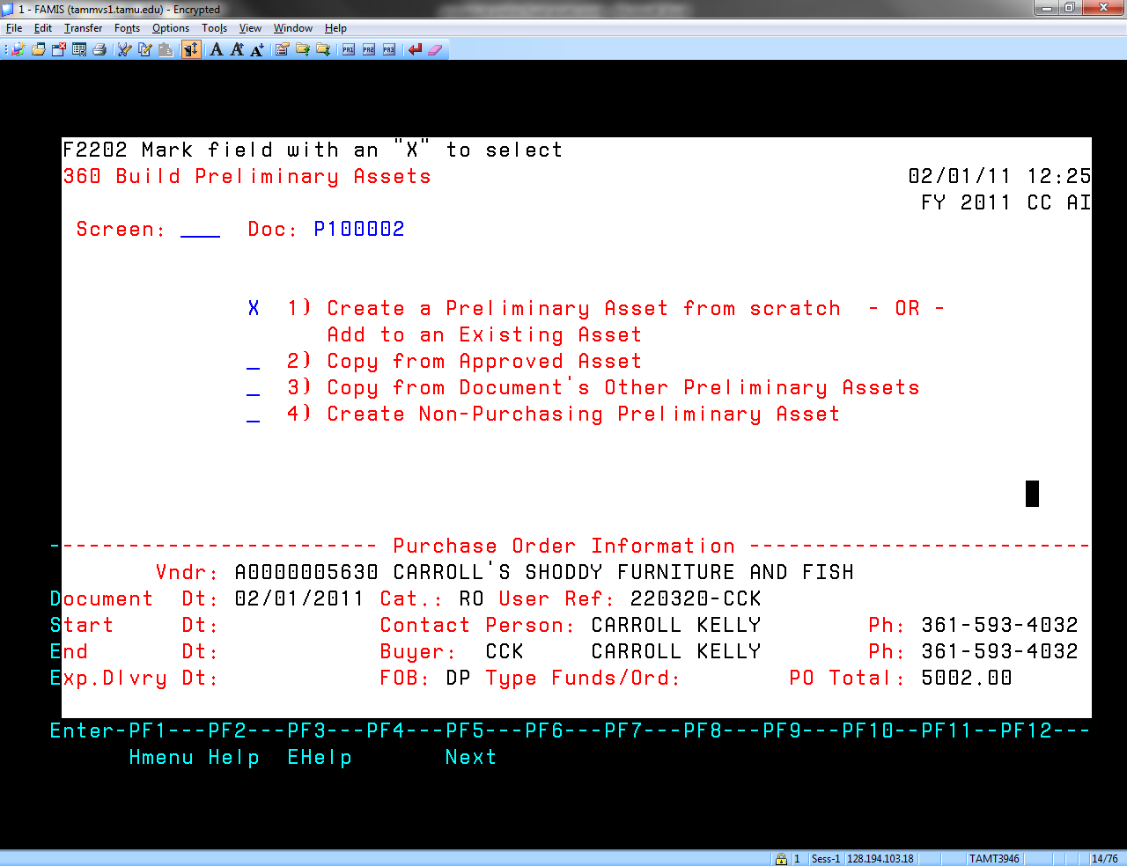

This pop up screen will be displayed.
“Nbr of Assets” field—enter the number of assets to create.
“Value” will be populated-it can be changed, for shipping etc. Must agree to invoice.
“Assign Number” -type “Y” if you desire a number to be assigned. If you desire the item to be added to an existing asset, type that asset number in “Add to Existing Asset Number”.
Press ENTER.
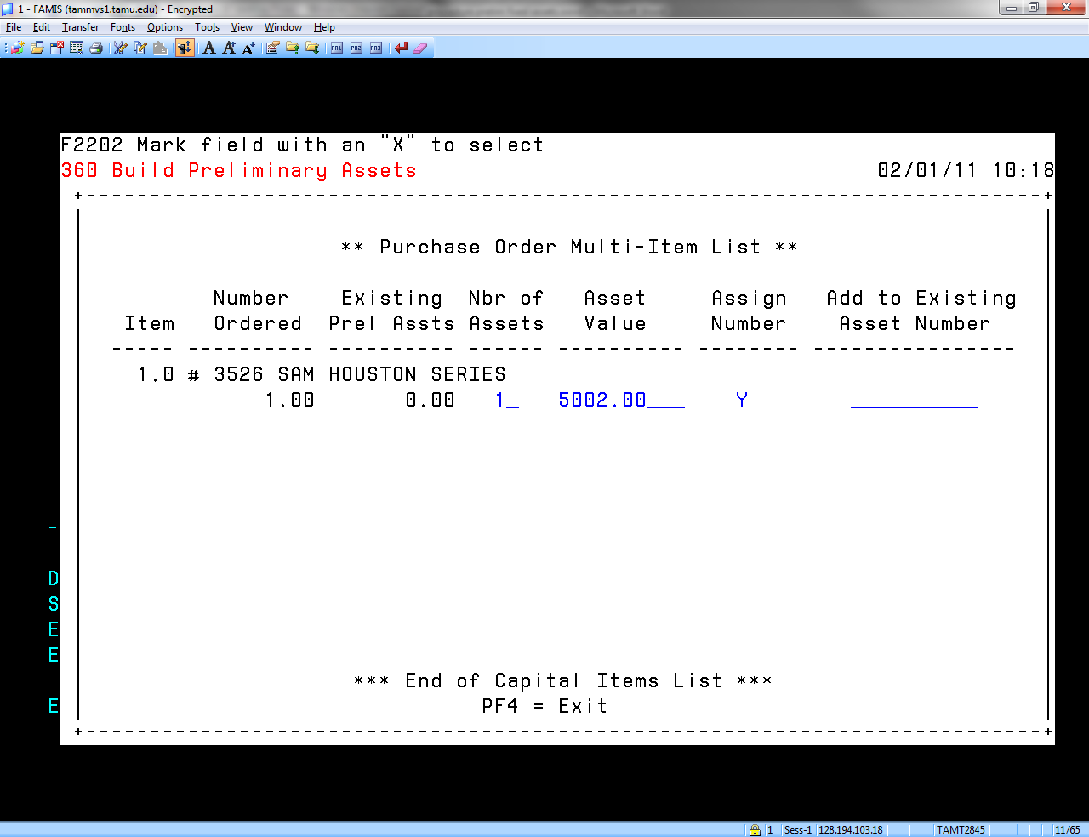

Screen 360 automatically pops up.
See information line at top-indicating that a FFX record has been created.
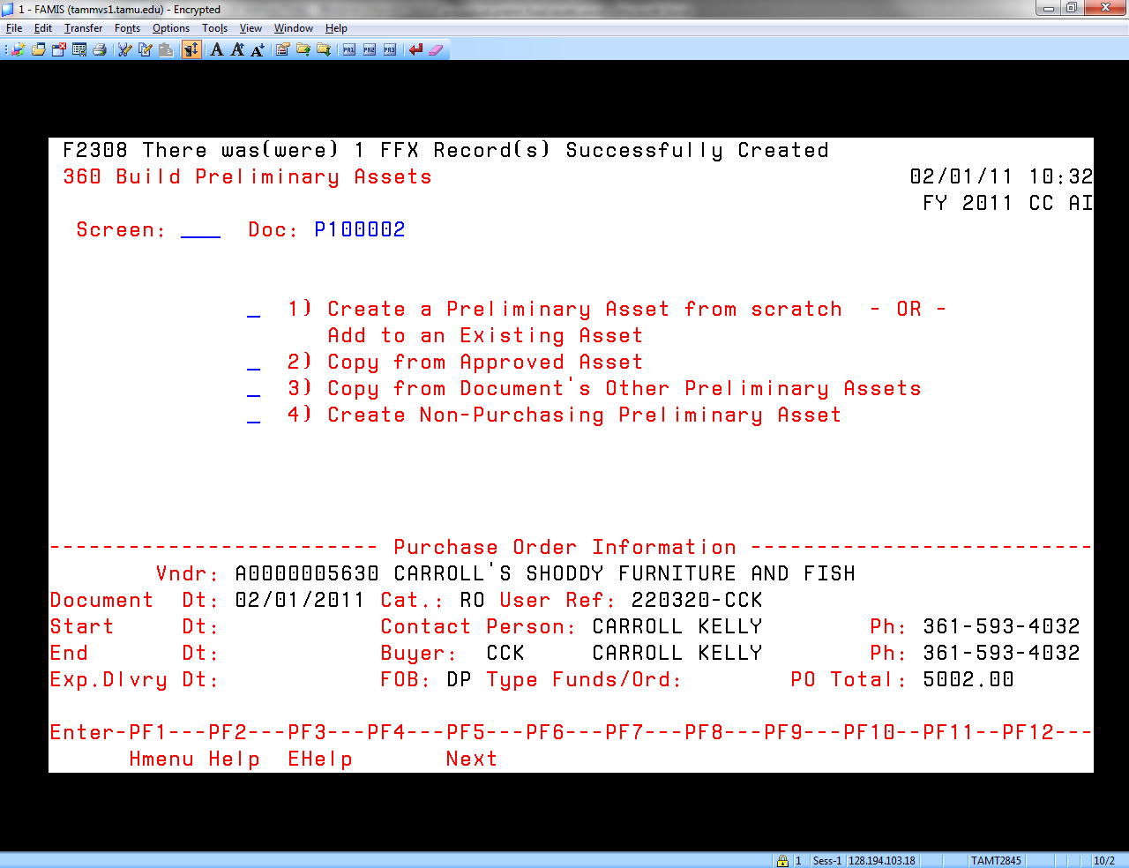

Enter 361 at screen field. Press ENTER or press F5.
The Preliminary asset number and details will be displayed.
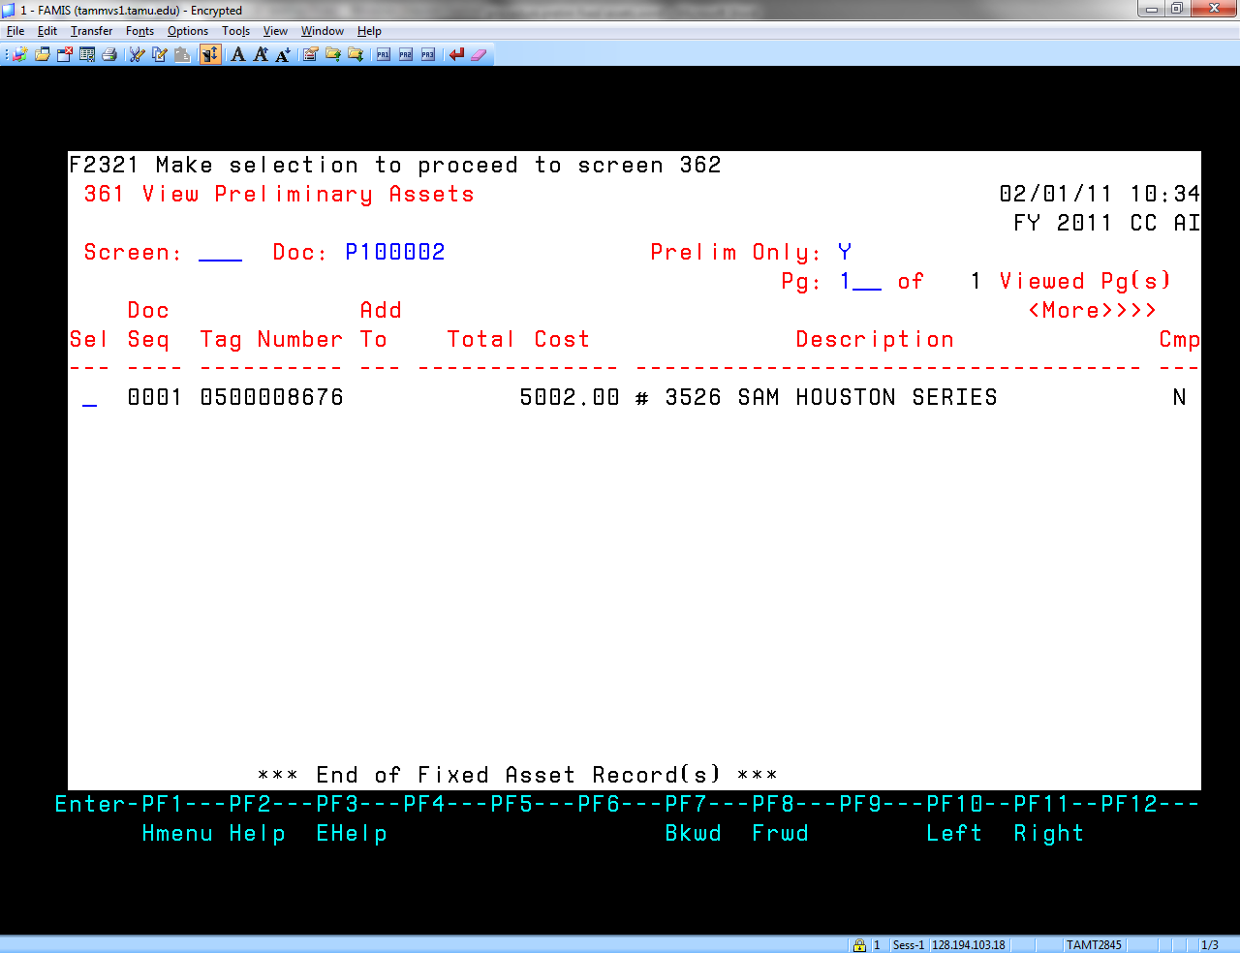

On screen 361, place an X beside the desired asset and press ENTER, to proceed to screen 362.
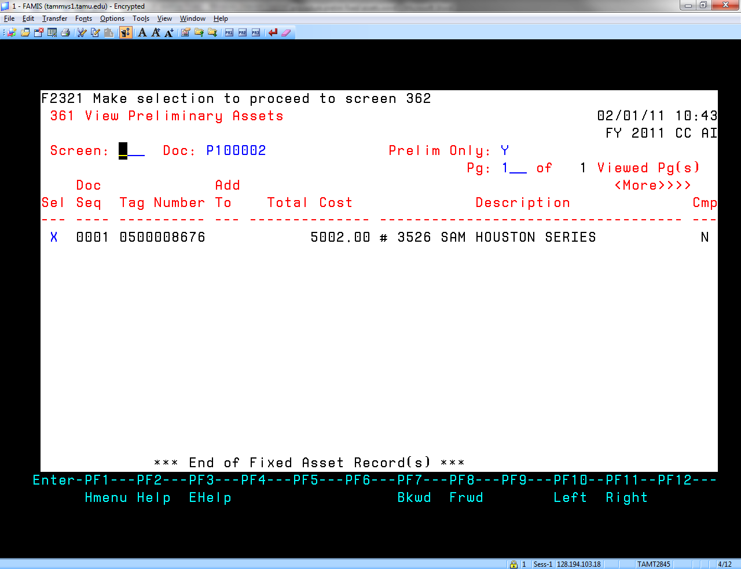

Screen 362 will be displayed. Items in blue are pre-populated.
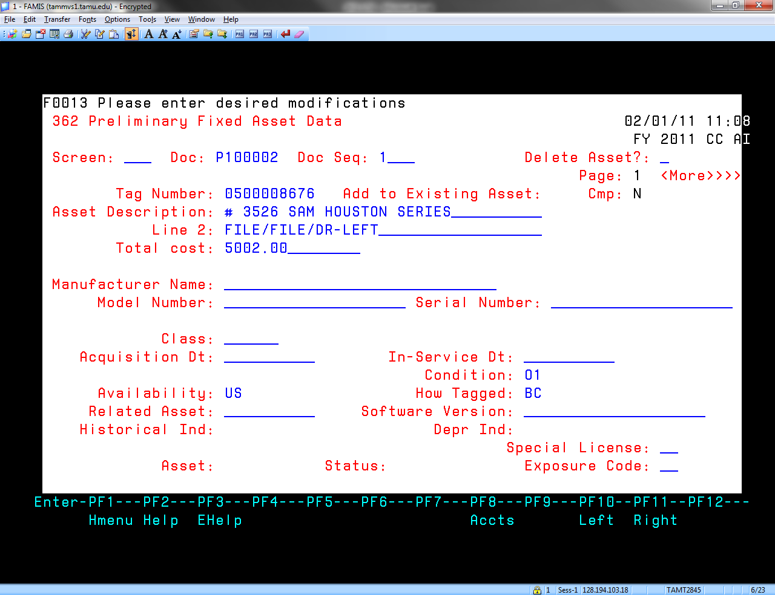

The description can be adjusted if needed. After changing, press ENTER.
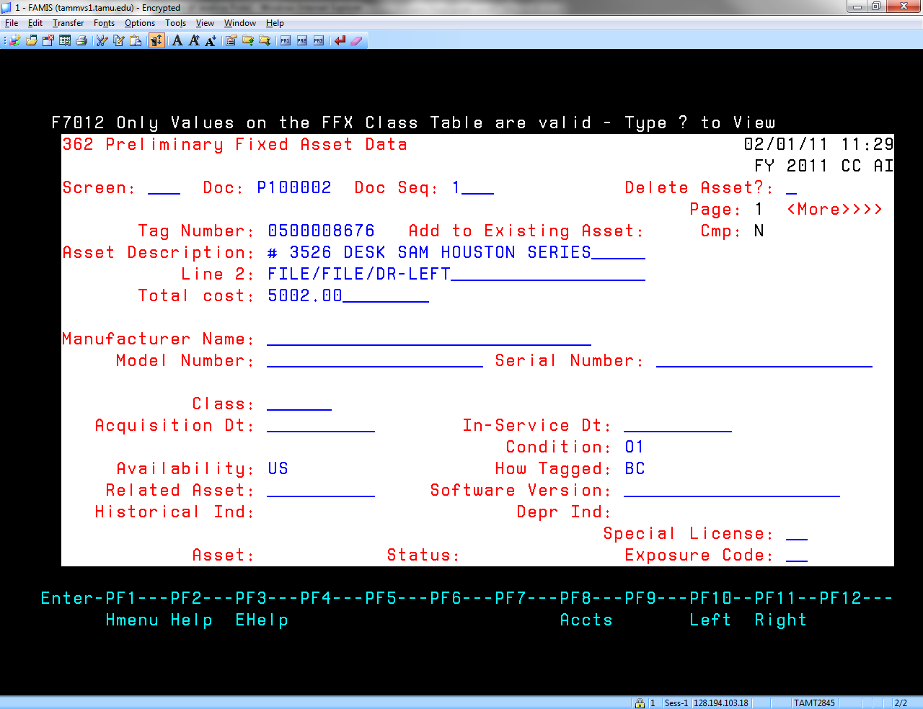

Cursor will flash at “Class”. See Appendix ”FFX TABLE OF CLASSES” to select the proper class code. The class code is the object code, plus two additional digits. The object code for the desk is “8421”, so the class code for Desks is “842103”, OR
Enter “?” at class field and pop up below will be displayed.

if not automatically displayed, enter the object code of the item, press ENTER. The applicable class codes will display. Place an “X” beside the class code desired. Press ENTER and the code will be populated on screen 362.

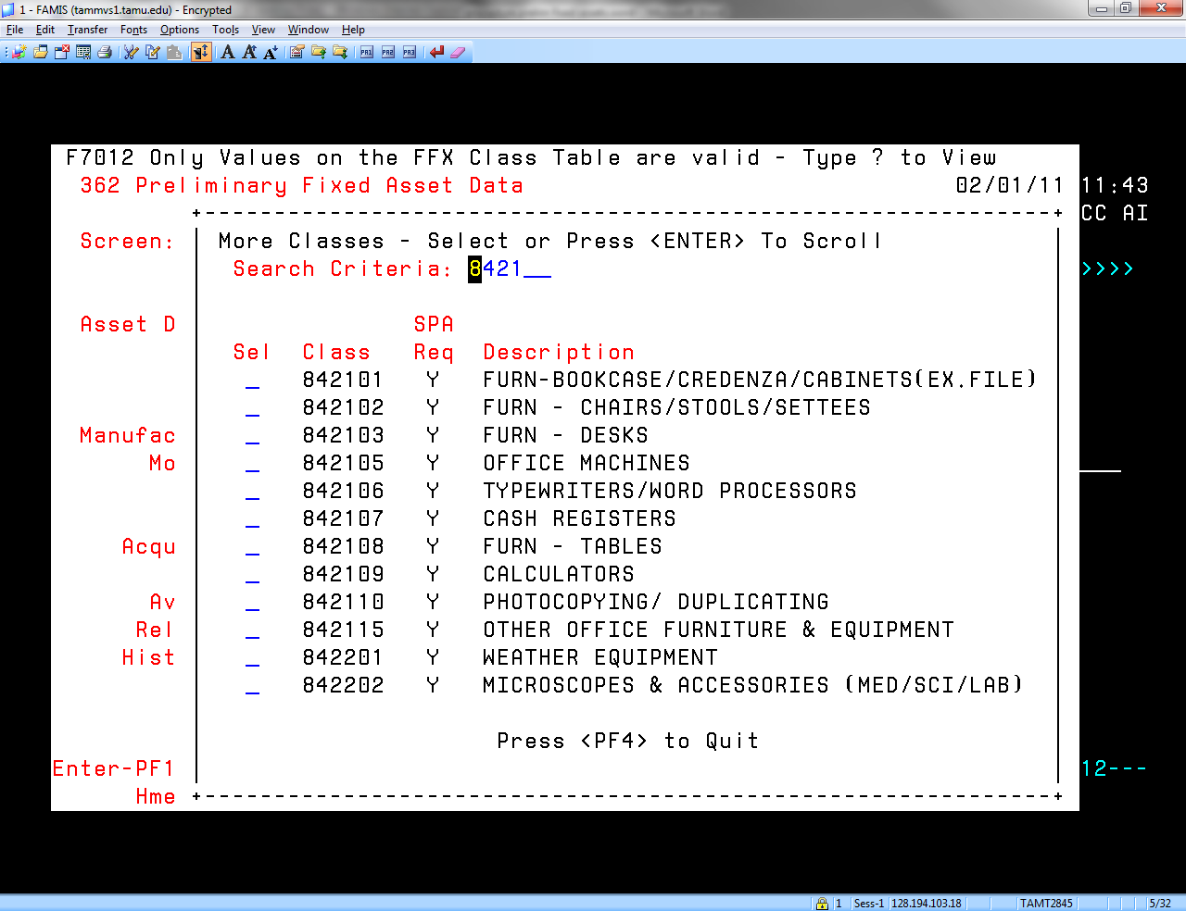

Screen 362 will now appear as follows after additional information has been added, i.e.: Mfg name, model #, serial number, received and in-service date. The more information, the better.

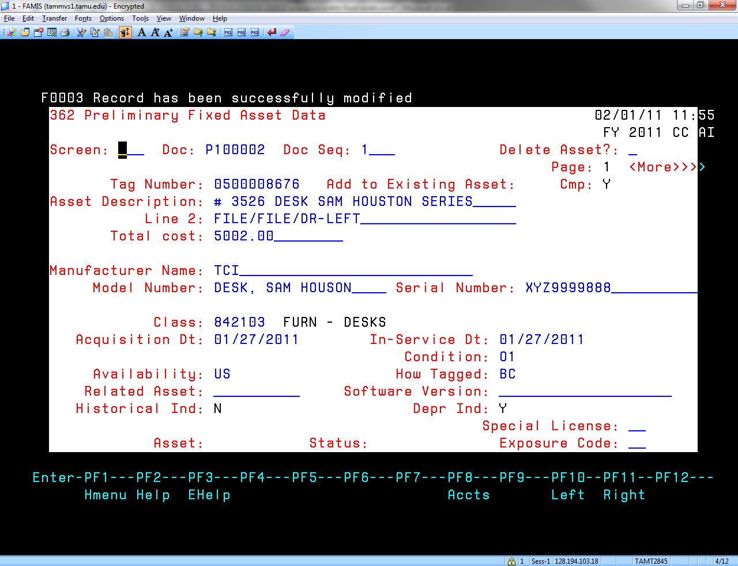

Press ENTER.

Screen 362, page 2 will now be displayed. Verify or enter the “Building”-see the appendix for building numerical codes. Verify the Building Campus, which will be 17. Enter the room number. Press ENTER.
CMP will now be changed to “Y”, indicating that the Preliminary Fixed Asset information has been accepted.
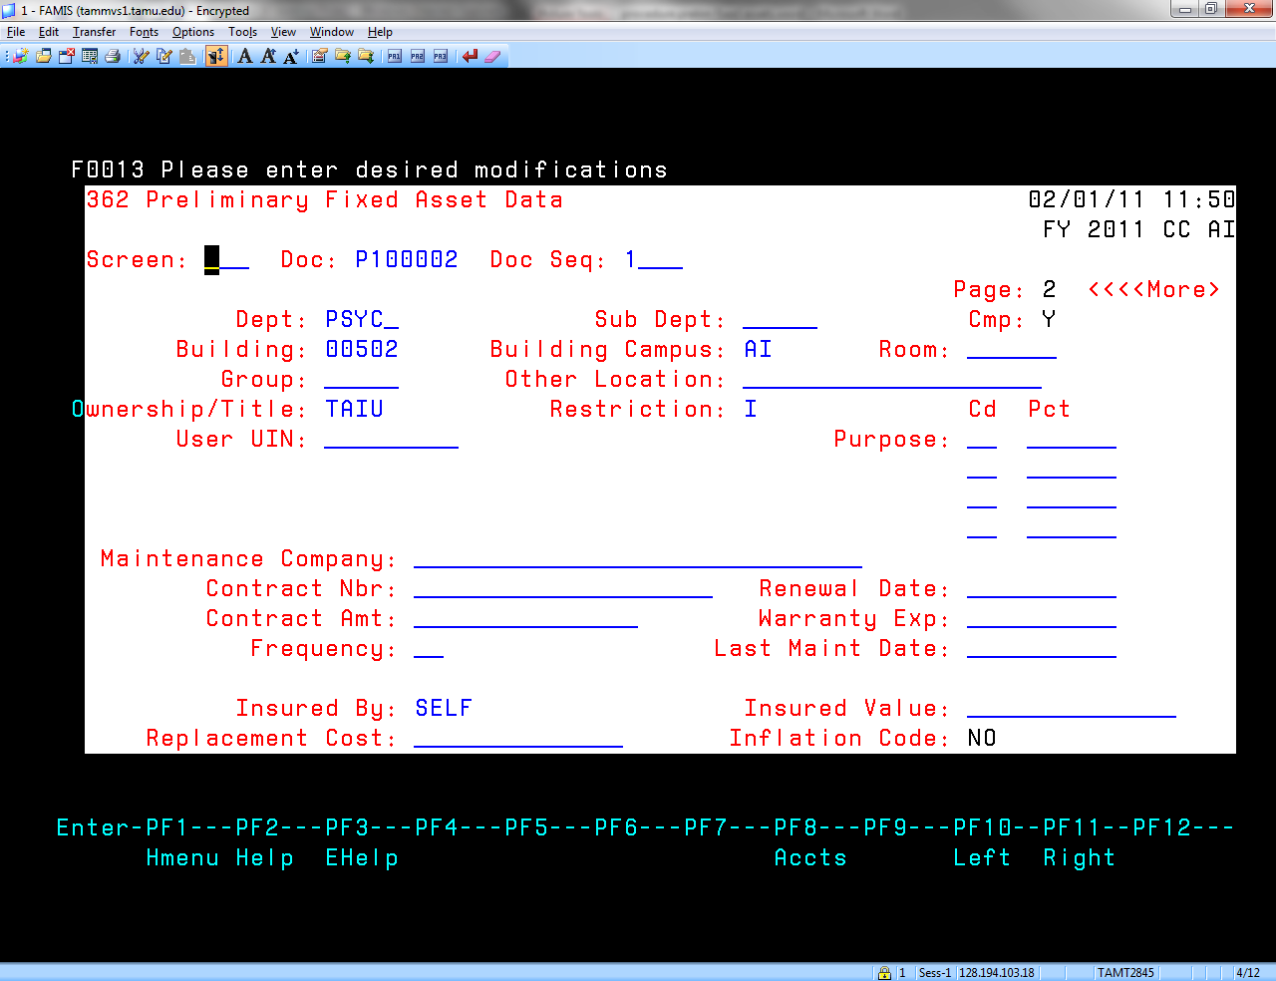

Enter screen 361 in the screen field. Cmp now indicates that the process is COMPLETE.

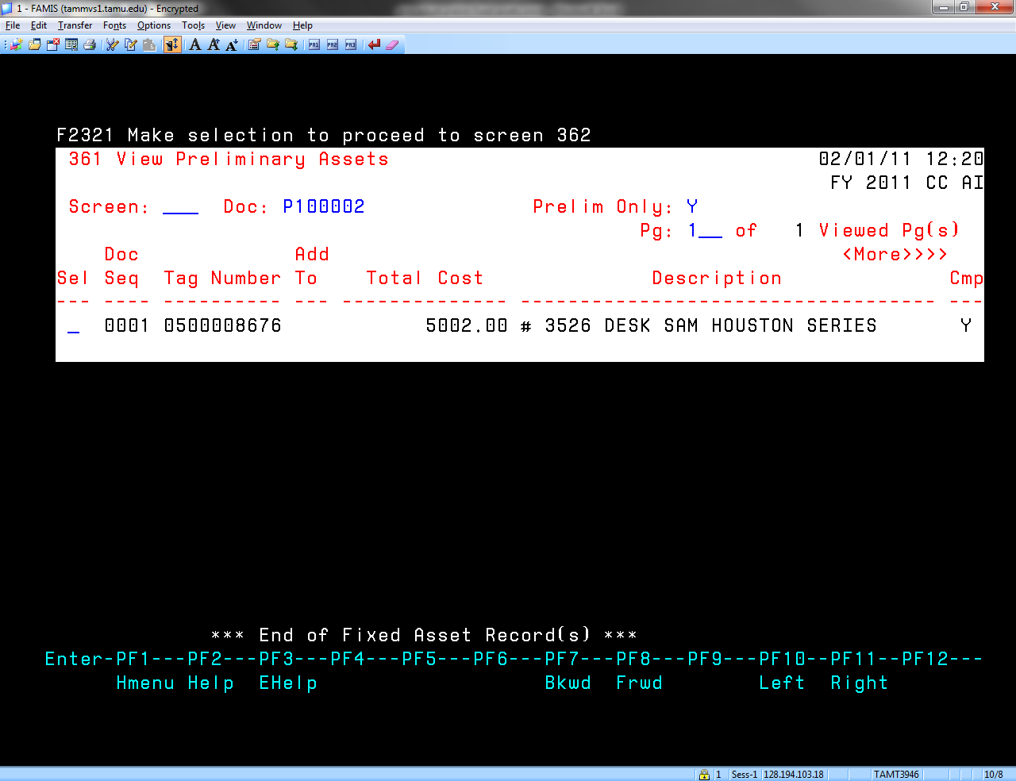

Preliminary Fixed Asset number assignment is now complete.
Proceed to screen 321 to process Electronic Receiving.

This is a separate example to show handling of -SHIPPING COSTS:
The following screen will demonstrate the process for including shipping into the value of the asset. Complete screen 361 as before.
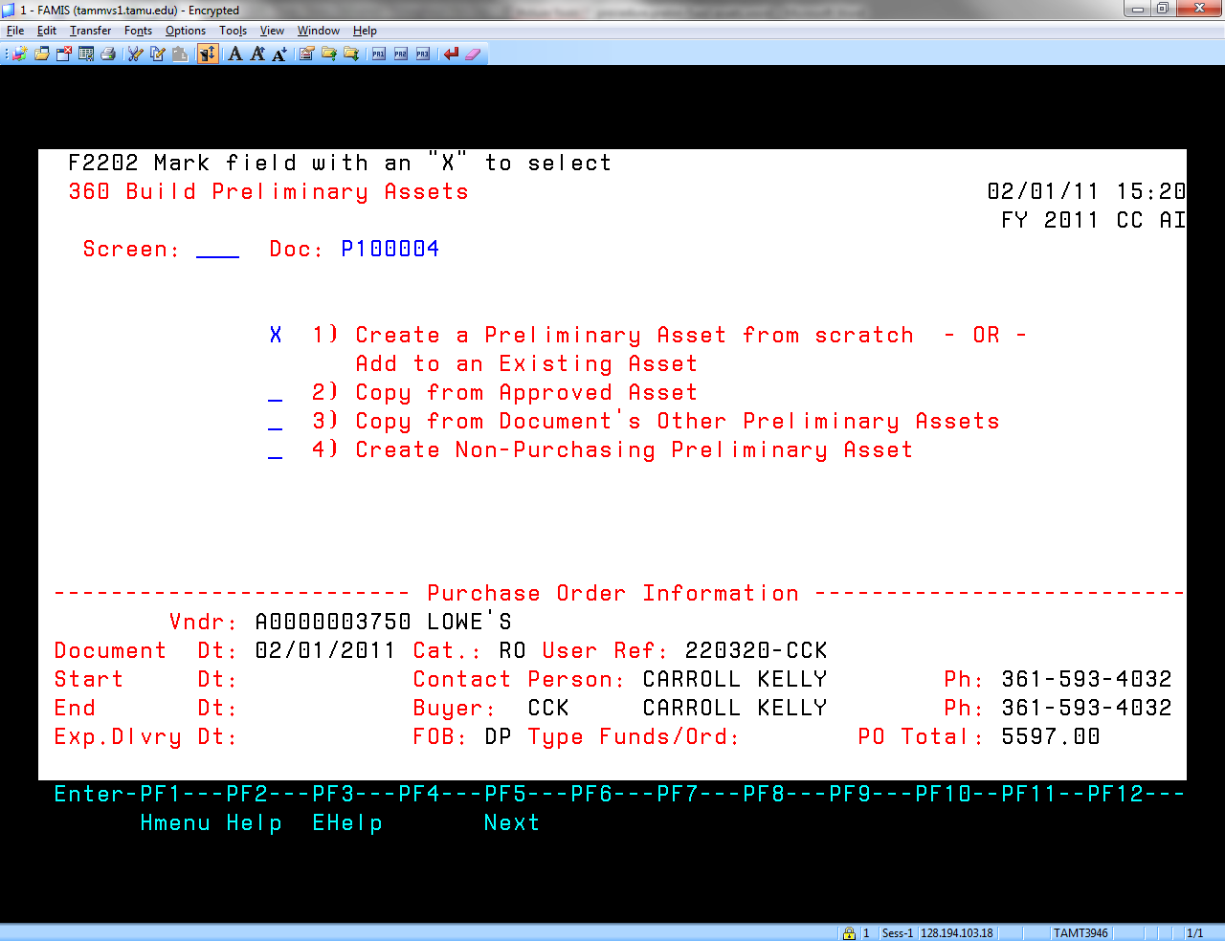

The pop up will be displayed as follows:
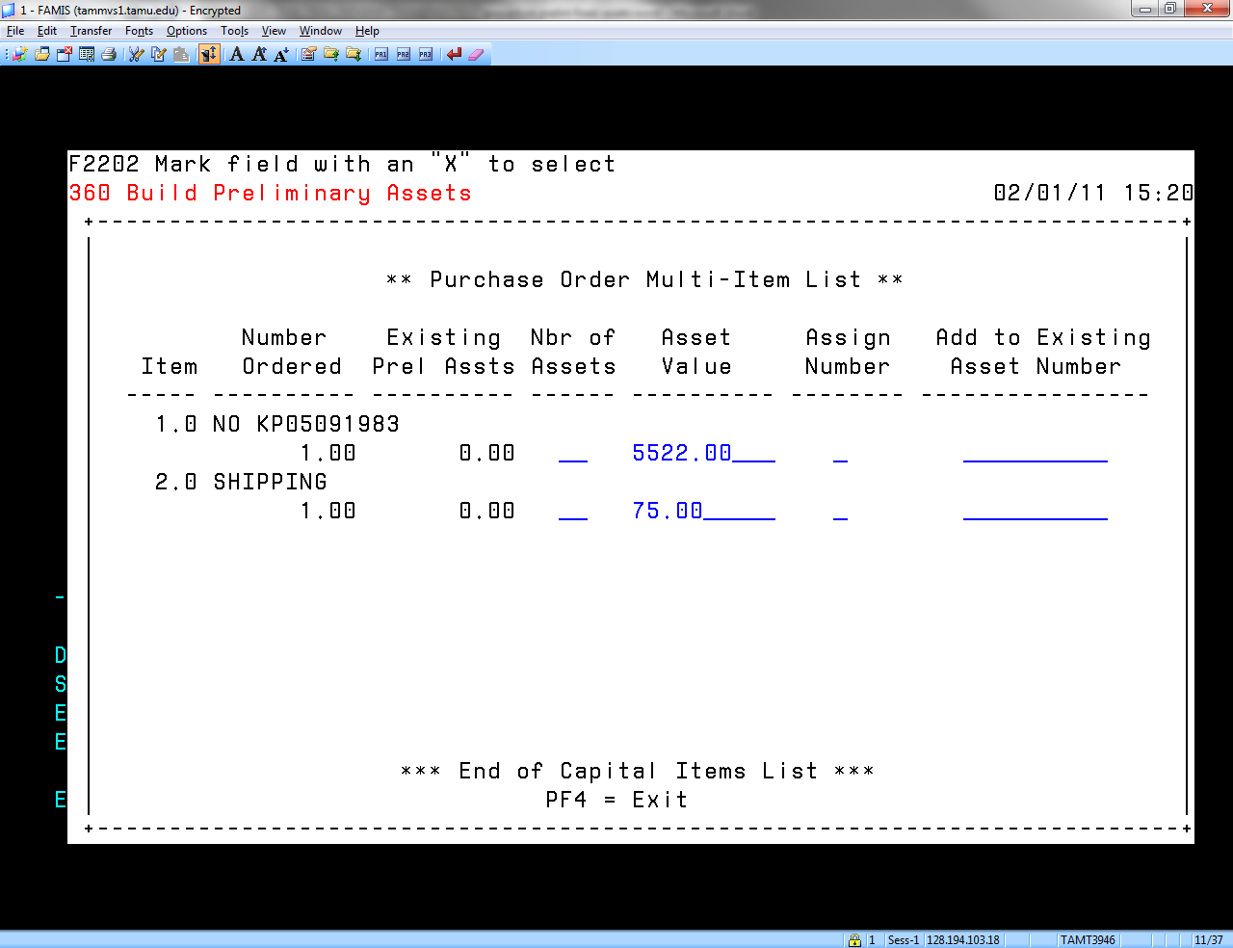

Manually increase the value of the asset by the amount of the shipping cost and change the shipping cost to zero. Press ENTER.
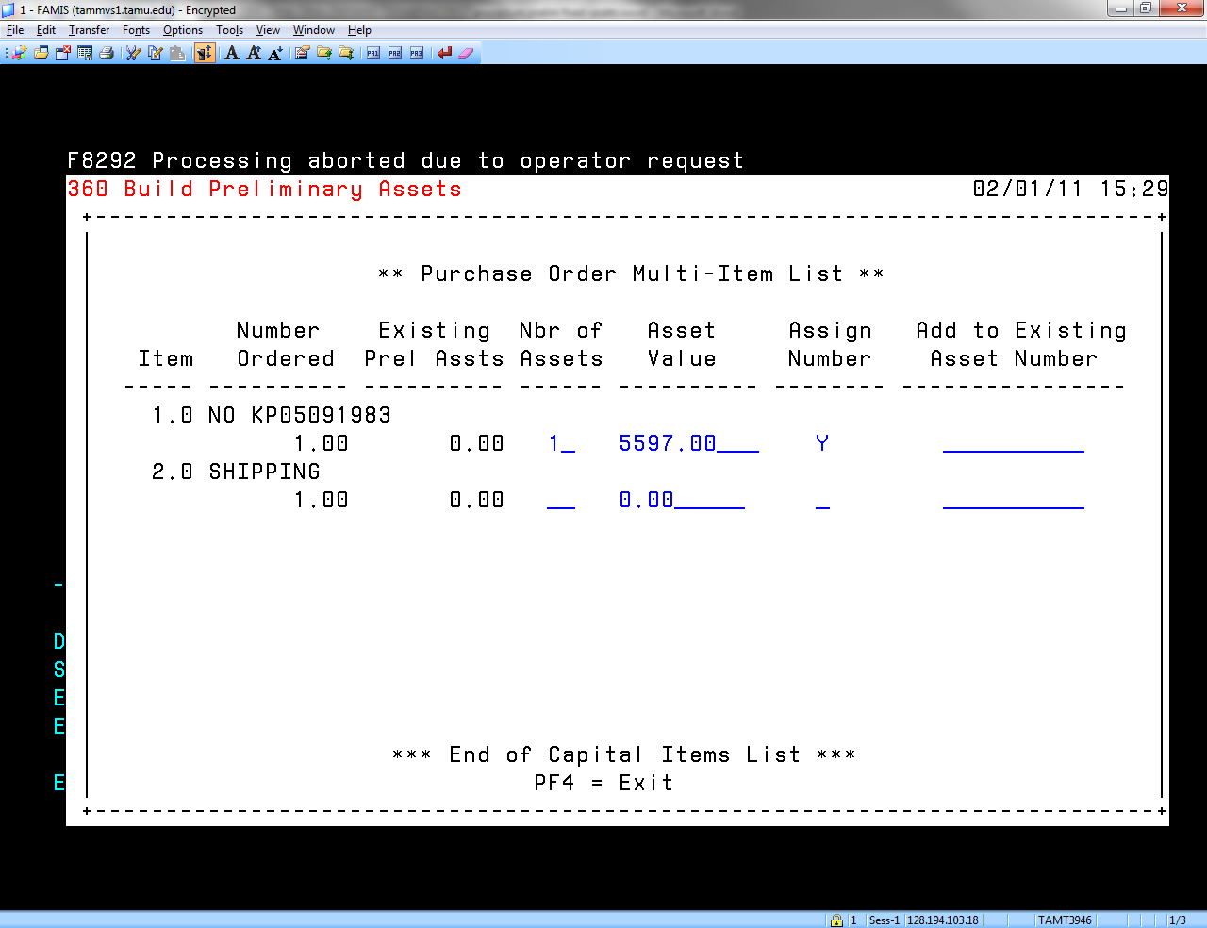

Screen 360 is automatically displayed and indicates that the asset has been added.

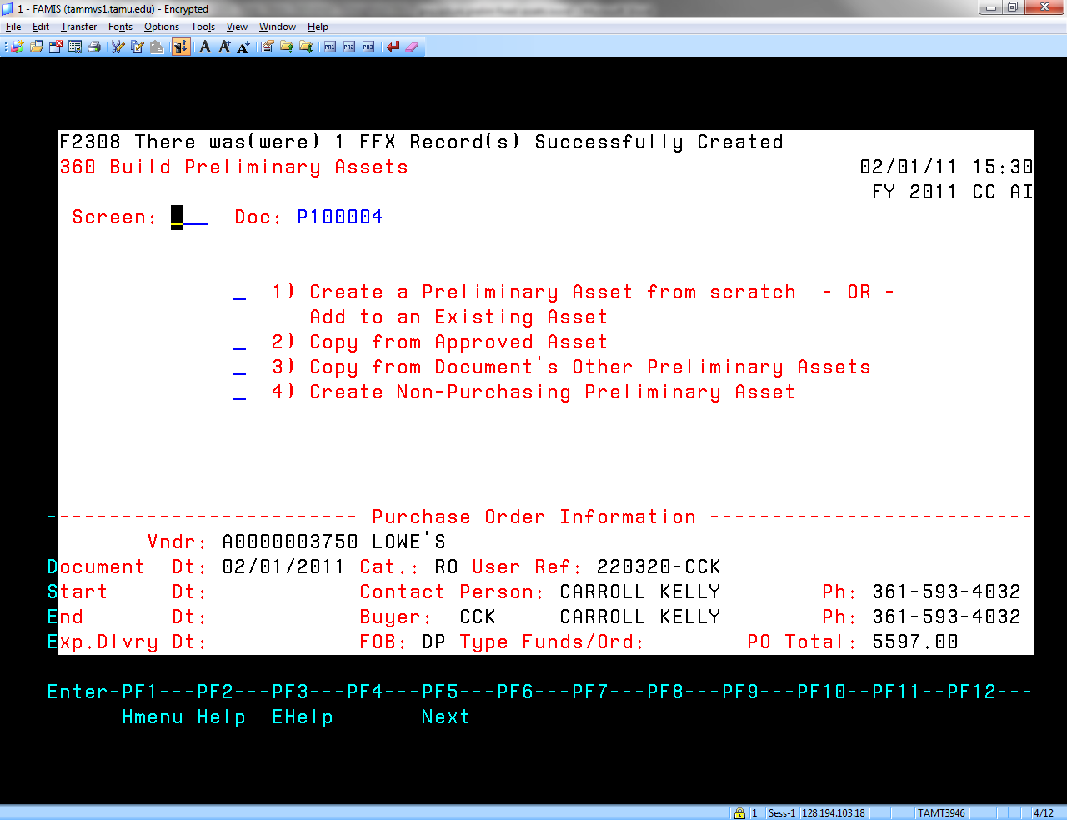

From this point the procedure is the same as the previous example-refer to page 7.
THE END.--

