Accessing Your Semester Schedule
on Blue and Gold
Step by Step Process
Texas A&M University- Kingsville

JNET to Blue & Gold to Main Menu
1
Go to jnet.tamuk.edu and sign in using your ku ID and university password. Click on Academic Records and then on Blue and Gold. This will open up on the Blue and Gold’s Main Menu.
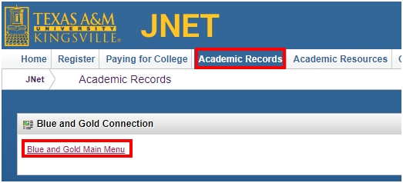
2
Registration
Once on the Blue and Gold Main Menu click on Registration.
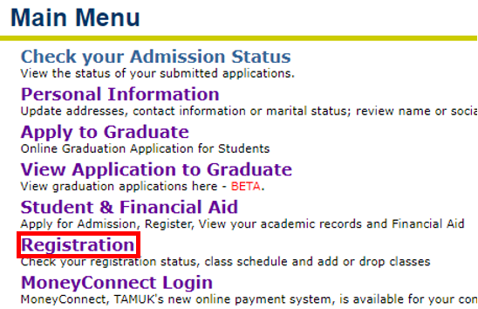

Week at a Glance
3
The week at a glance schedule allows you to visually see the time slots of the week and how your classes are laid out. After clicking Registration click on Week at a Glance.
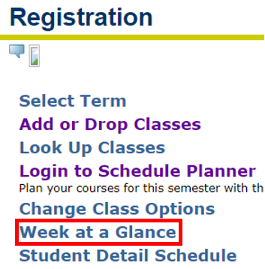
Interpreting Week at a Glance
4
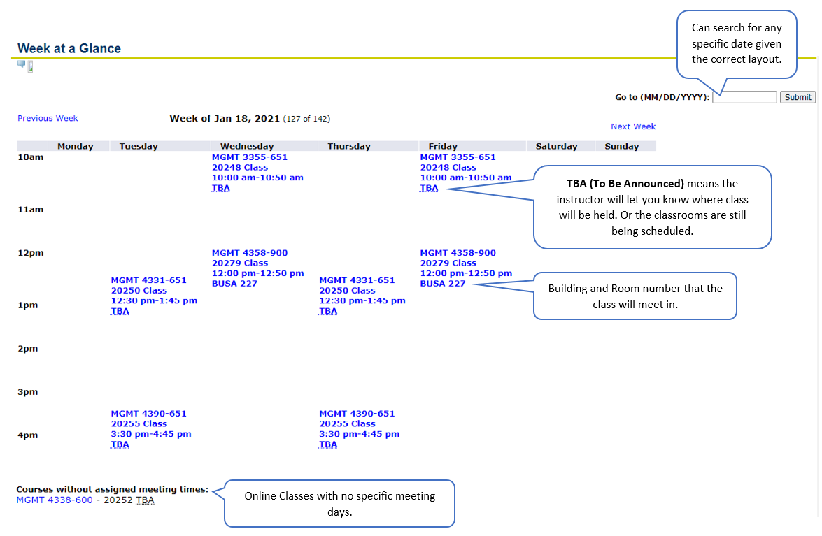
Student Detail Schedule
5
For a more detailed version of your schedule go back to the Registration Menu and click Student Detailed Schedule. This version of your schedule provides you with more information regarding your class than the week at a glance schedule.
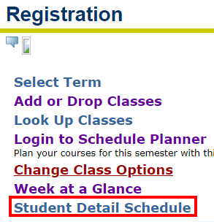
Click the drop down box and select the semester you wish to view. Click Submit.
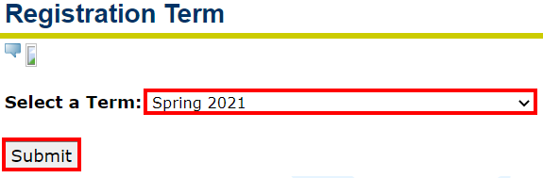
After clicking Submit your page will refresh and you will see detailed schedules separated out by each course you are taking that semester.
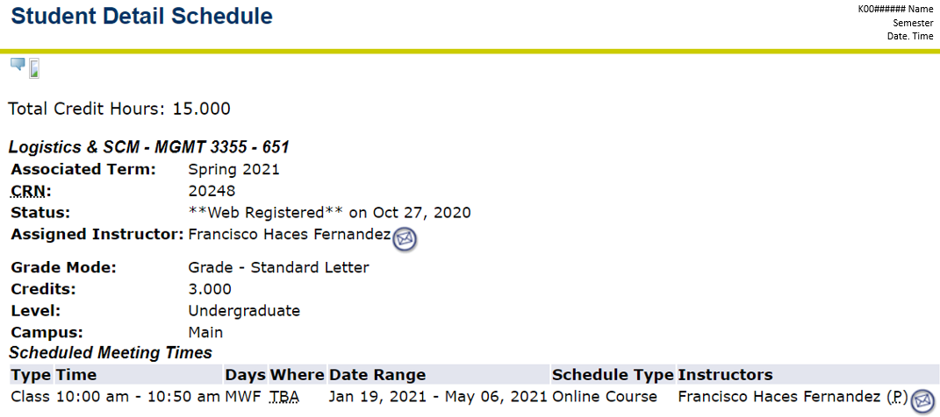
Understanding Class Sections

Each course has a code and right after that code there is a section code. The section code tells you what type of class it is. For example, hybrid, face-to-face, etc. Below is a list from tamuk.edu that explains what each section code stands for.
For example, based on the week at a glance schedule above, there is a class labeled: MGMT4338-600. Because of the 600 code this lets me know it will be mostly online.
NOTE: Temporary Covid-19 Course Definitions
Some course offerings and modalities since Fall 2020 semester have been temporarily changed due to the COVID-19 pandemic. Please refer to the Javelinas Care, Protect page linked below that will contain all of the current information regarding these new course definitions.
https://www.tamuk.edu/return/index.html#Academics

Internet Courses (Section 600)
A course in which 85% or more of the planned instruction occurs when the students and instructor(s) are not in the same place. This type of course may have mandatory face-to-face sessions totaling up to 15% of the instructional time. Examples of face-to-face sessions include orientation, laboratory, exam review, or an in-person test.
(face-to-face time) = less than or equal to 15%
(web-substituted content) = greater than or equal to 85%

Hybrid / Blended Courses (Section 900)
A course in which a majority (more than 50% but less than 85%), of the planned instruction occurs when the students and instructor(s) are not in the same place. Learning management systems enhance delivery with pre-declared (on course schedule) face-to-face substitution.
(face-to-face time) = less than 50%
(web-substituted content) = greater than 50% and less than 85%

Web-Substituted (Section 500)
A course in which no more than 50 percent of the planned instruction occurs when the students and instructor(s) are not in the same place. Learning management systems enhance delivery with pre-declared (on course schedule) face to face substitution.

Web-Enhanced
A course in which no planned instruction occurs when the students and instructor(s) are not in the same place. Learning management systems enhance course delivery without face-to-face substitution.

Videoconference Courses (Section 400)
TTVN (formerly known as the Trans-Texas Videoconference Network) is the wide area data and interactive communications network that serves the campuses and agencies of the Texas A&M System. The network also serves a number of affiliated colleges and universities, K-12 school districts, and state agencies throughout Texas. The core TTVN network consists of over 100 primary wide area network sites and more than 300 videoconference sites.

Face –to- Face (Any other Section Number with “00”)
Unless indicated the rest of the section codes will be face to face. This means you will meet on campus during the days and times listed for the class you registered for.

