Graduation Application
Step by Step Process
Texas A&M University- Kingsville

JNET to Blue & Gold to Main Menu
1
Go to jnet.tamuk.edu and sign in using your ku ID and university password. Click on Academic Records and then on Blue and Gold. This will open up on the Blue and Gold’s Main Menu.
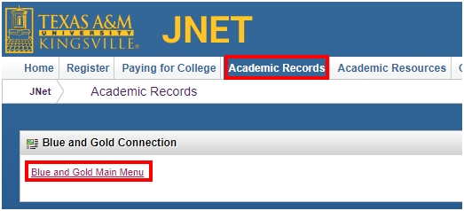
On the Blue and Gold Main Menu click on Apply to Graduate.
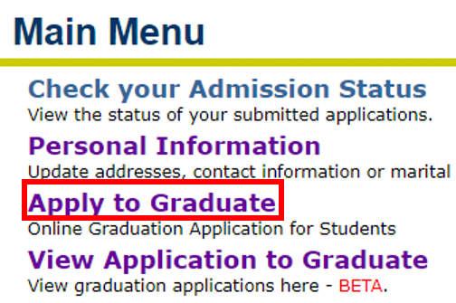
2
Term Selection
Click on the drop down box and Select the Term /semester you will be graduating. If you are not registered for a future semester the current semester will automatically be selected.
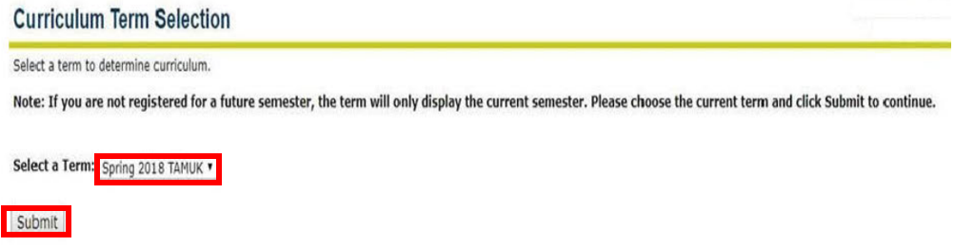
Selecting the Curriculum
3
Select the Curriculum/ degree that you are eligible to graduate with. If you see an issue or something does not look right contact your advisor immediately. If everything looks good select the Current Program and click Continue.
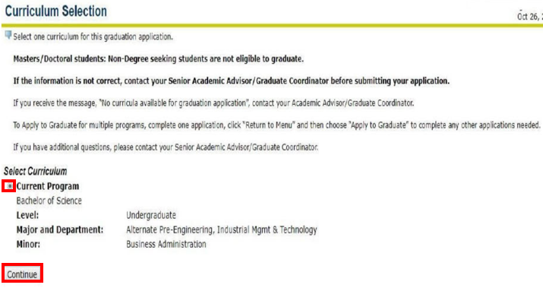
4
Graduation Details
After Submitting the Curriculum Details you will be asked to select the graduation date and choose whether or not you plan on attending graduation. After each selection be sure to click Continue.
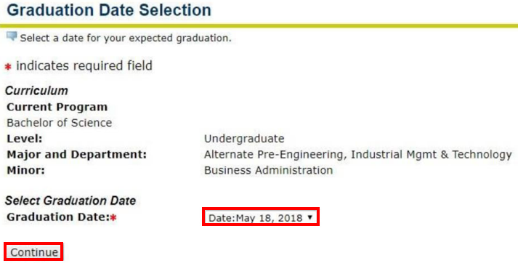
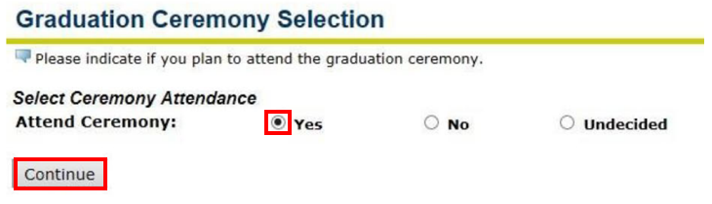
5
Diploma Details
If you see this section come up please pay close attention to detail. Make sure that your name is spelt correctly and the mailing address for your diploma is correct. Be sure to think months in advance to mail your diploma to a secure place where you know the address will not change. Diplomas are sent after all grades have been submitted for that semester. Once all the grades are submitted it takes 6-8 weeks for the diploma to be shipped to the designated address, which is what you are just about to fill out.
**If you do not see this section please refer to our Address and Phone User guide to add the Diploma Mailing Option.
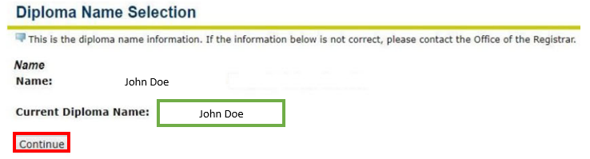
Make sure this is CORRECT
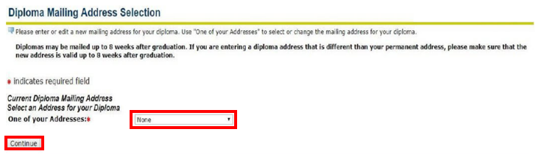
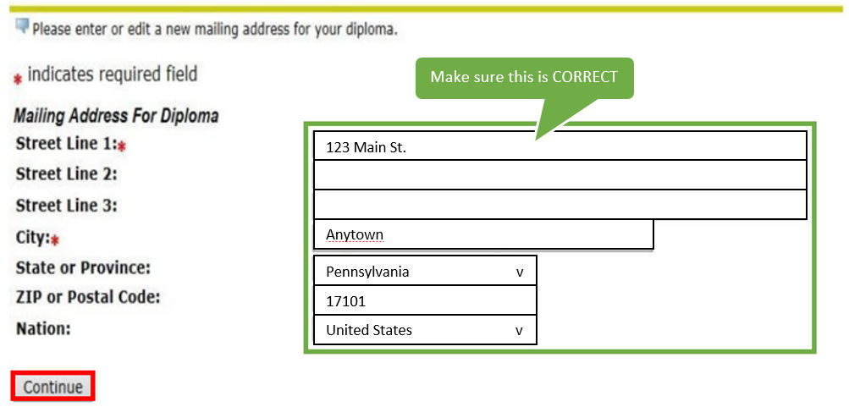

Graduation Application Summary
Make sure that once you are done with the application you take time to overlook the application. Check for spelling, typos, and incorrect information. Here at TAMUK we want to make sure you do not have to worry about anything after you receive your diploma. To help prevent any future issues we highly recommend double checking everything. Diplomas will have the name as indicated in the TAMUK student information system and your degree.
Note: For certain Colleges, the degree and major will be indicated on the diploma. Diplomas DO NOT include minors or concentrations. Minors are shown on the University official transcript. If you have lost or damaged your original diploma and/or wish to have a duplicate copy of your diploma you can fill out a Duplicate Diploma Order Form. Additional diplomas are $25.
Contact Information
- For further information about your diploma and graduation contact the Provost Office at (361)593-106.
- If you need to make a name change go the Registrar’s website https://www.tamuk.edu/registrar/
  - Click on Forms > Students > and under General Forms click on Change of Personal Data Form. Fill out the form and email it to the Office of the Registrar at registrar@tmauk.edu

Congratulations on Graduating!

