The Javelina Engineering Student Success Center (JESSC)
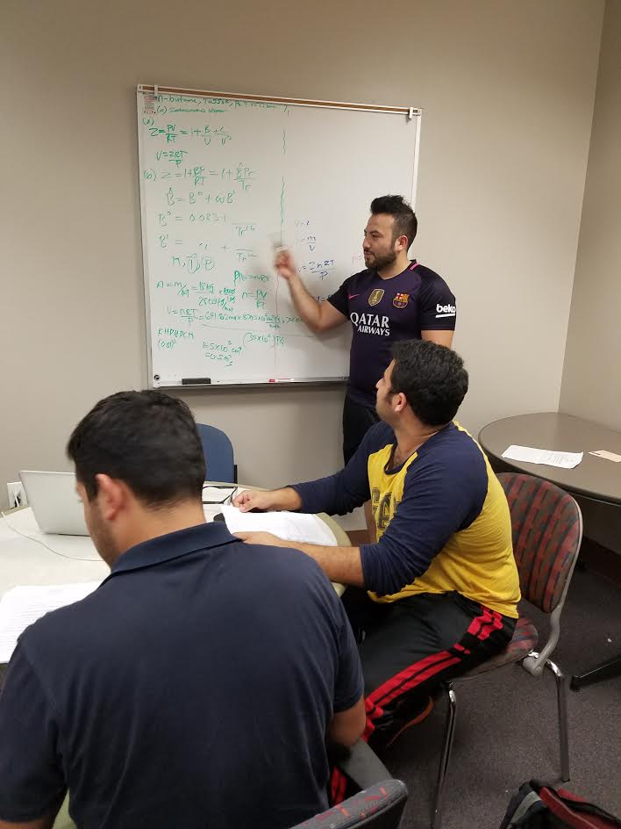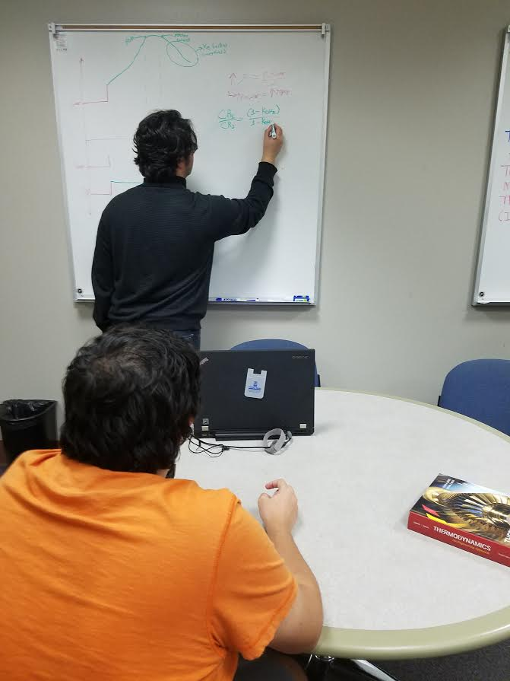

Our mission is to increase retention in the Frank H. Dotterweich College of Engineering, and to provide our students with the tools they need to succeed. The JESSC also encourages, engages, and promotes student leadership skills and activities that develop integrity, quality, and the ethical commitment in students’ professional careers.

We do this by:
- Providing tutoring at multiple sites around campus for introductory engineering classes as well as math, chemistry and physics.
- Providing a thorough transcript evaluation for new transfer students
- Coordinating student organization activities through the Engineering Student Council.
- Notifying students of professional development opportunities and important academic deadlines.
- Establishing a tracking system to monitor academic progress for all students.
- Establishing activities through the Living Learning Center in the residence halls for a better support system.

Current JESSC Services
- In-house Academic Advisors.
- In-house resource center to enhance research and study skills.
- Student Organization led mentoring available for transfer students.
- In-house Coordinator of Internships and Co-operative Education.
- Providing a centralized location for
Scholarship information Posted job opportunities
Internships/co-ops Interview sessions with visiting companies,
Degree program audits Other university activities
and timely degree checkout
- Offers personal sessions with representatives from the Office of Career Services on:

For more information, contact: (361) 593-4376

